Lost in the jungle
Warm up
- The pictures below are from a story of some people who got lost in the jungle. What can you see in them? What do you think happened? Tell your partner.

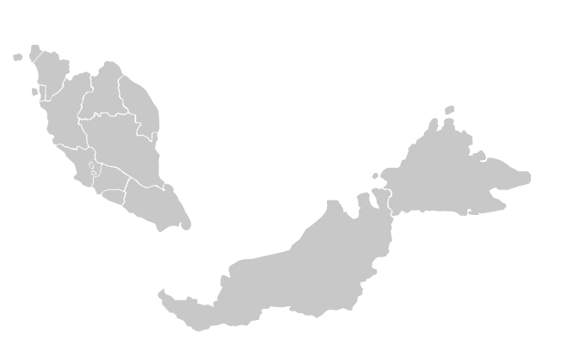
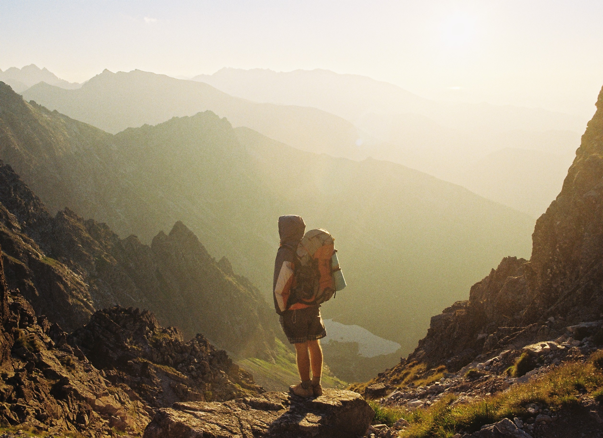
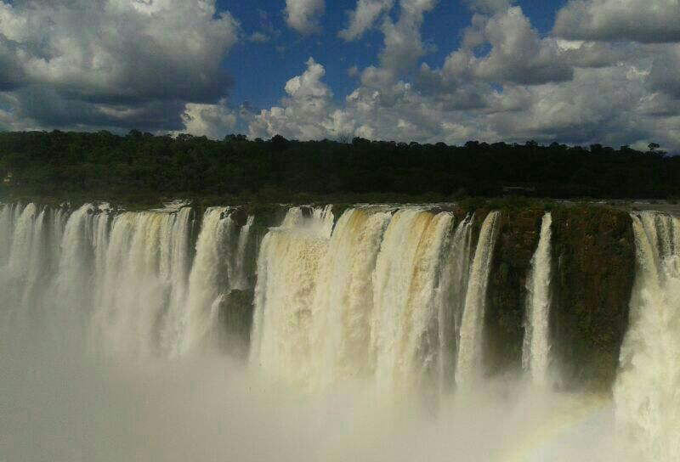

- Read the first part of the story:
British Backpackers lost in Malaysian Jungle!
When three British backpackers got lost in the Malaysian jungle with no food or water, they thought they might die. They spent two terrifying days in the jungle trying to escape. How did they get rescued? Thanks to the advice of TV adventurer Ray Mears!
Chiara and Rory Maddocks and Rachel Hodson went on a short trek to visit a famous waterfall on Langkawi island in Malaysia. They didn’t take any food or special equipment with them and they wore shorts and flip-flops. The trek became very difficult and after 3 hours of walking the friends decided to go back. As they were walking through the rainforest to return to their car, the friends realized they were lost. Three hours later they were exhausted and very thirsty because they had no water or food to eat. Nobody knew where they were, and it was getting dark…

What is the problem? What do you think happens next? Discuss with your partner and then share your ideas with the class.

Vocabulary

- Complete the sentences with the correct word from the box.
backpacker waterfall exhausted rescue
flip-flops advice rainforest terrifying

- ________________ are plastic sandals you wear at the beach.

- ________________ means very frightening.

- ________________ means to feel very tired.

- ________________ is the opinion someone gives you on what is the best thing to do.

- A ________________ is a person (often young) who goes travelling using cheap transport and carrying all of their things in a large bag you carry on your back.

- If you ______________someone, you save someone from a difficult or dangerous situation.

- A _____________ is an area where water flows from high rocks down into a pool below.

- A tropical wood that gets lots of rain and has very tall trees is a _____________.

- Match the words to the pictures

coast cliff jungle tropical insects
fisherman storm bruise
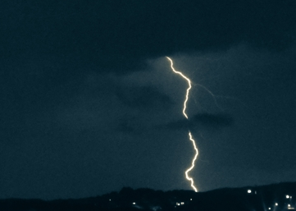
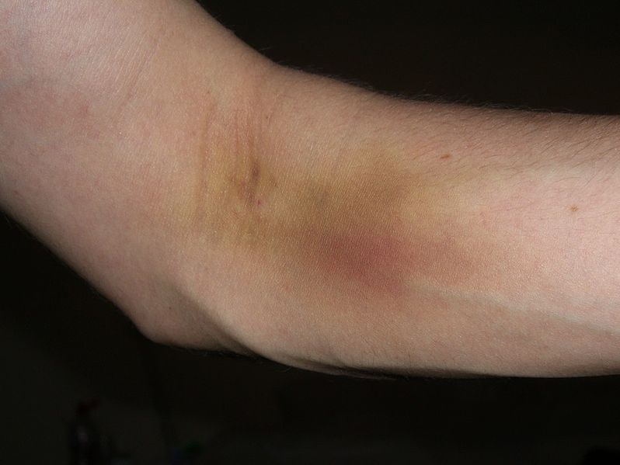

1.________________________ 5.______________________

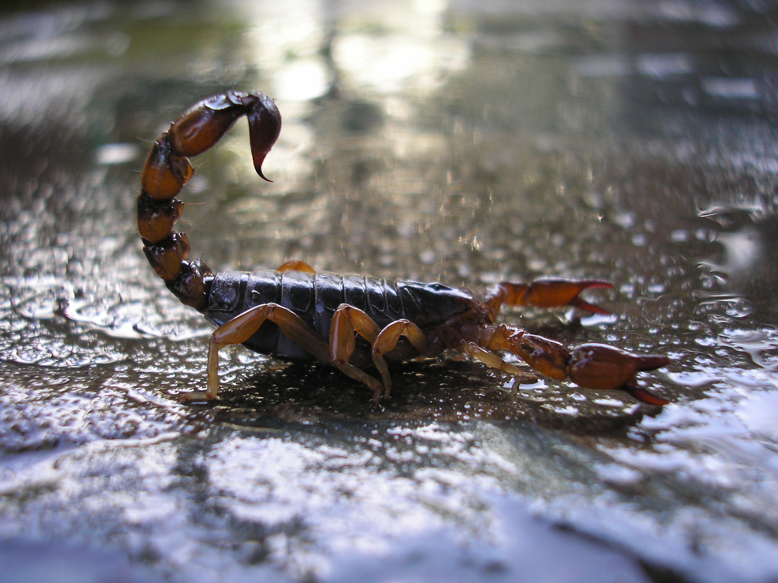
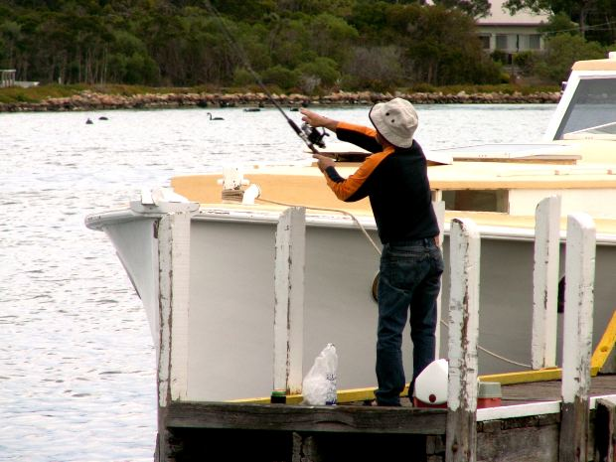

2._______________________ 6.______________________
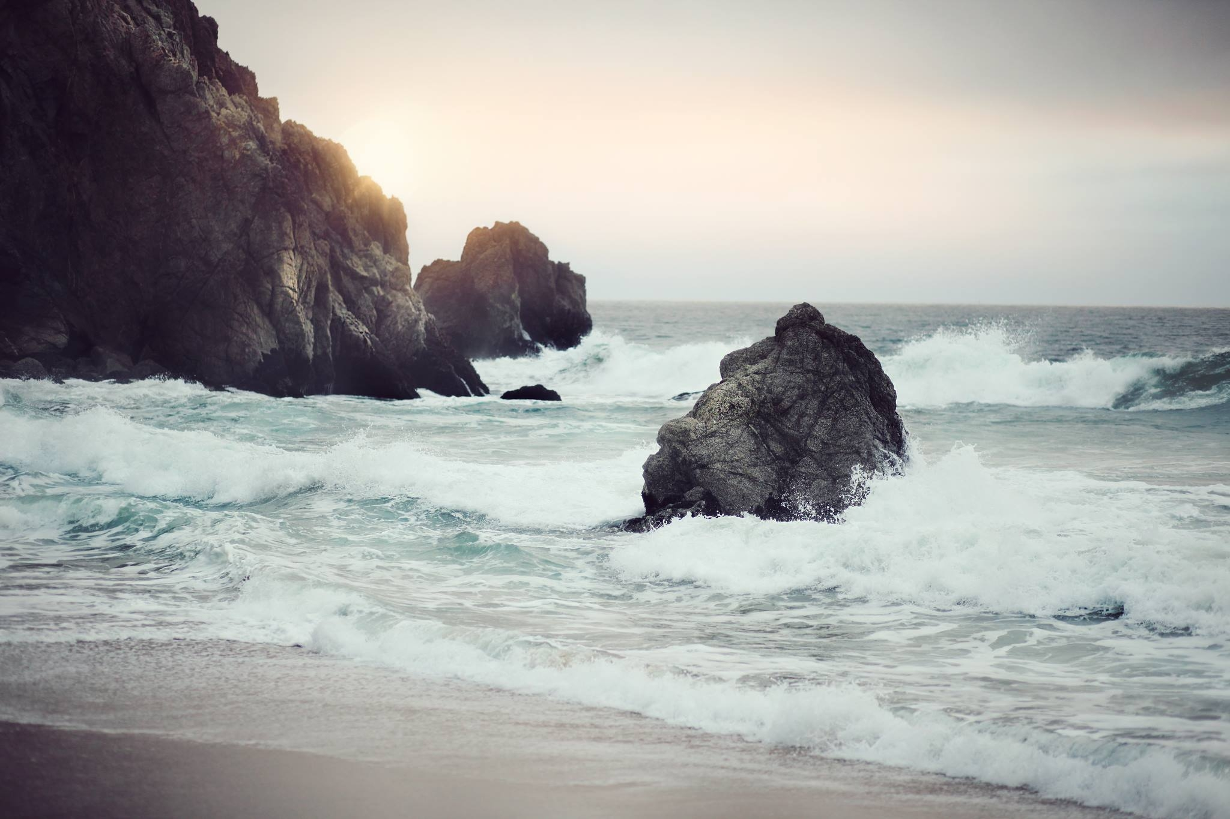
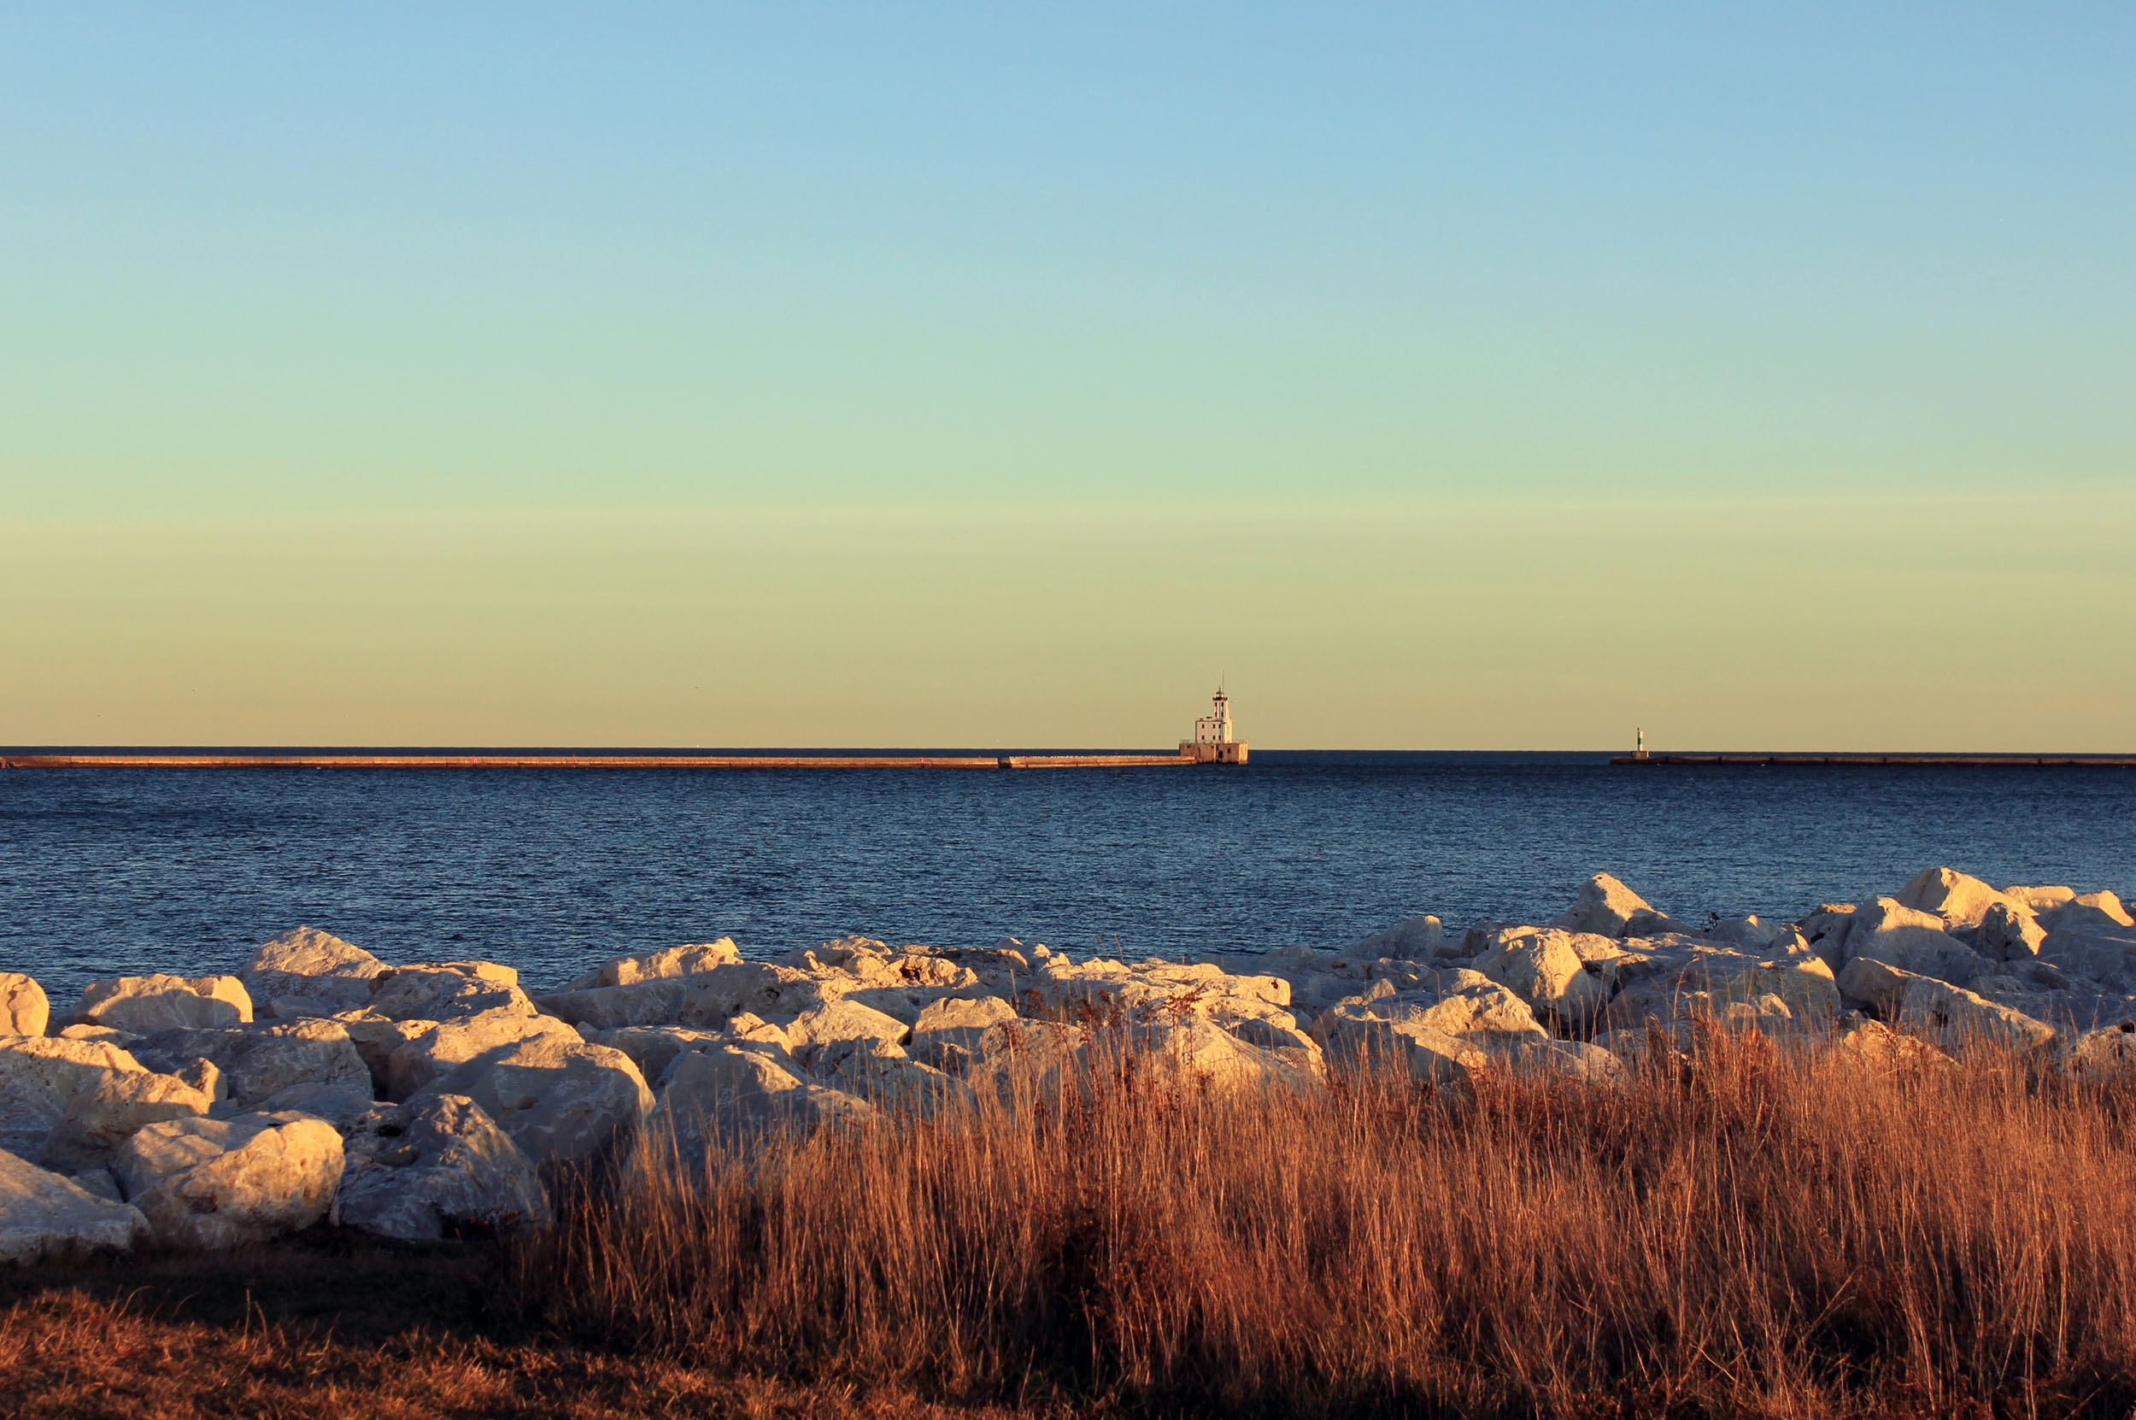

3._______________________ 7.______________________
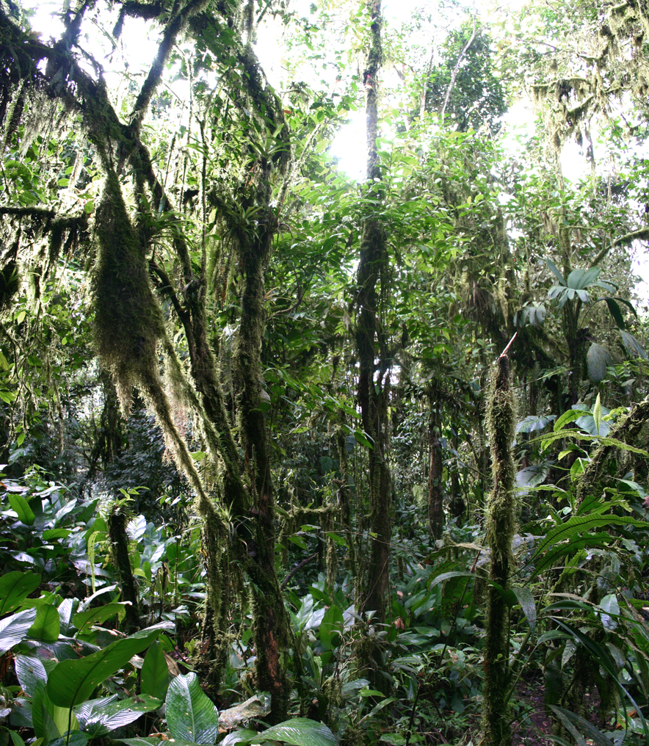

4.______________________
Reading
- Read the rest of the story and find out what happened next.

The backpackers spent the night in the jungle. There were lots of tropical insects and there was a big thunderstorm with lots of rain. Fortunately Mr Maddocks remembered advice from the show 'Ray Mears' Extreme Survival'. Ray said that you can follow a river to find your way to the coast. The next day, the friends followed the river but unfortunately at the end there was a big cliff above a high waterfall. They climbed down the dangerous rocks, until they found the coast and a beach. They could see boats in the sea so they decided to swim to them to get help. But the sea was very rough and dangerous, and they almost drowned. Another day later they had some luck. A fishing boat sailed past, and the fisherman saw the friends and came to rescue them. They were dehydrated, and had lots of cuts and bruises from climbing on the rocks.
After the rescue Mr Maddocks said: 'I'll never miss an episode of Ray Mears from now,'
'You never know when you might need it.'

Dehydrated = when a person is ill because they don’t have enough water in their body.
Drown = to die because you are under water for too long and can’t breathe.

- Choose the correct option in each sentence.

- The backpackers slept a) in a hotel b) in the jungle.
- The weather was a) very wet b) very dry.
- Mr Maddocks a) watches ‘Ray Mears’ at home b) watched ‘Ray Mears in the jungle’.
- The backpackers followed the river and they found a) the coast b) a big cliff and a waterfall.
- The backpackers tried to swim a) to get help b) because they were bored.
- The fisherman a) sailed past the friends b) came to rescue the friends.
- Mr Maddocks a) wants to watch every Ray Mears programme in the future b) is never going to watch Ray Mears again.

Grammar: Past simple regular and irregular verbs.
- Look at the sentences below. Underline the past simple verbs. How do we make a regular verb past simple? How do we make a negative sentence and question?

- The backpackers spent the night in the jungle.
- Mr Maddocks remembered advice from Ray Mears.
- Where did the backpackers get lost?
- They didn’t take any food.

- Can you complete the table with irregular past simple verbs from the texts?
Infinitive | Past Simple
1. spend
2. get
3. think
4. have
5. be
6. go
7. say
8. can
9. see

- Complete the sentences with the correct form of the past simple

- A fisherman ___________(rescue) the backpackers.
- They __________(think) they might die.
- The friends _______ (walk) for a long time.
- The backpackers ___________(not take) any water with them.
- The advice of Ray Mears ____________(save) the backpackers.
- They ________(be) in the rainforest when they ____________(get lost).
- The backpackers _________(not wear) very suitable clothes for trekking in the jungle.

Listening
http://www.youtube.com/watch?v=5fcMbAHLXBo
- Watch and listen to Ray giving advice about camping in the jungle. Complete the missing information in the sentences below.

- Ray says he has walked ______km today.

- Ray is setting up camp at _____ before it goes dark.

- A hammock keeps Ray off the ground and away from ________ and ____________________.
- The most important piece of equipment is a ______________________so that you don’t get malaria.

- Wood in the rainforest is often _________.

- Ray enjoys the sound of the Howler ____________.

- The lady twisted her _____________.

Speaking
- Look at these regular past simple verbs. How do we pronounce the ‘ed’ ending? Put them into the correct column in the table.

wanted realised remembered laughed helped
followed drowned climbed hated looked

/d/ | /t/ | /Id/
rescued | watched | decided

Practice saying the verbs correctly.

- Imagine you are a newspaper reporter interviewing one of the backpackers. Make the words below into questions using the past simple.
- Which country / you /go/ on holiday to?
- Who /you/ go/ with?
- Where /you/ go /trekking?
- Where / you / sleep?
- How /you/ feel? Why?
- How /you/ get/ rescued?

- Now work with a partner. One person is the newspaper reporter; the other person is one of the backpackers. Take turns to interview each other about getting lost in the jungle.

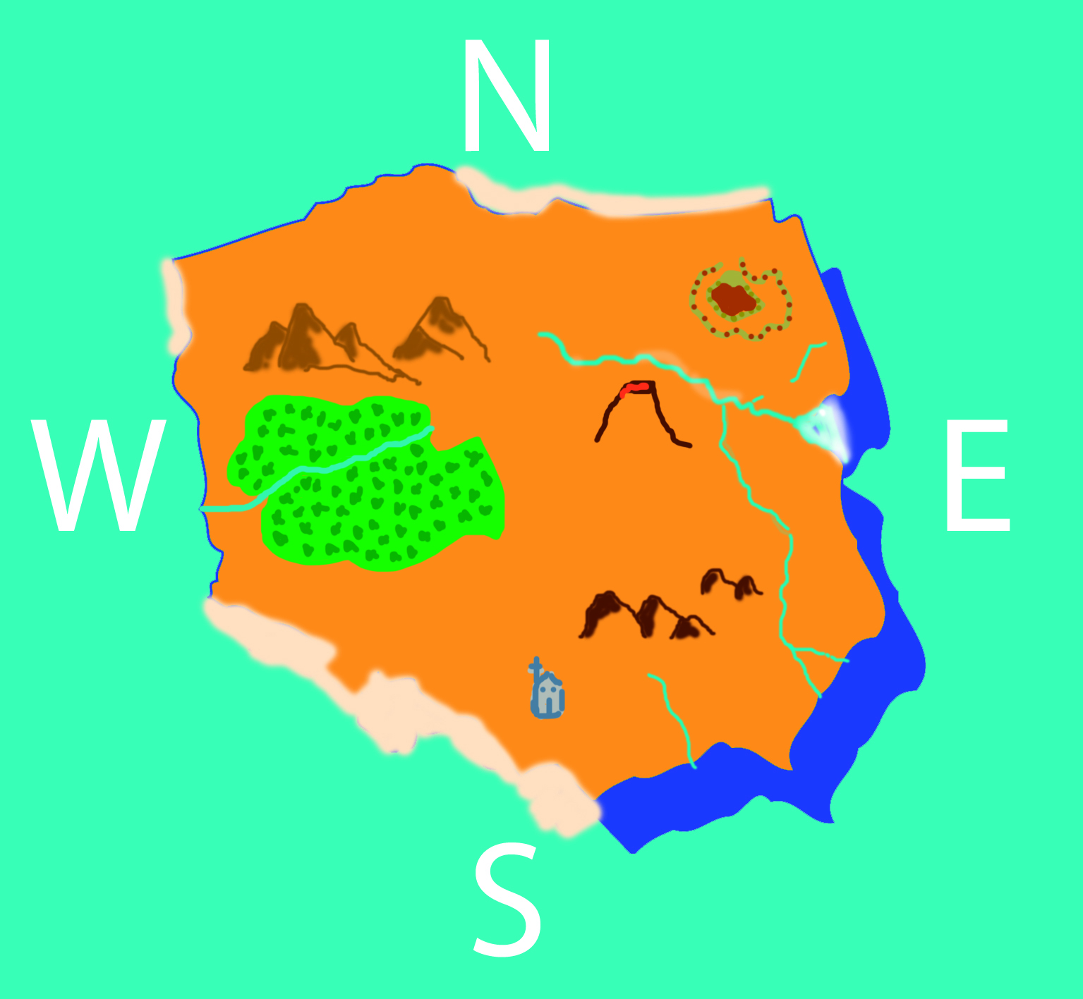
Writing
1.

Look at the map. Where is/are the…?
Mountains
Volcano
Waterfall
River
Coast
Rainforest
Castle
Temple

2. Imagine that you and your friends got lost on this island. Write about what happened. Say: Where you were, who you were with, how you felt, how you got lost, what happened, how you got rescued.
_________________________________________________________________________________________________________________________________________________________________________________________________________________________________________________________________________________________________________________________________________________________________________________________________________________________________________________________________________________________________________________________________________________________________________________________________________________________________________________________________________________________________________________________________________________________________

Answers
Vocabulary
1.
- Flip-flops.
- Terrifying.
- Exhausted.
- Advice.
- Backpacker.
- Rescue.
- Waterfall.
- Rainforest.

2.
- Bruise.
- Fisherman.
- Coast.
- Jungle.
- Storm.
- Tropical insects.
- Cliff.

Reading
2.
- b.
- a.
- a.
- b.
- a.
- b.
- a.
Grammar
1.
- The backpackers spent the night in the jungle.
- Mr Maddocks remembered advice from Ray Mears.
- Where did the backpackers get lost? (Question)
- They didn’t take any food. (Negative sentence)
Add –ed to a regular verb to make it past simple.
Use didn’t + infinitive verb to make negative past simple.
Use did + infinitive verb to make a past simple question.
2.
Infinitive | Past Simple
1. spend  2. get  3. think  4. have  5. be  6. go  7. say  8. can  9. see | Spent  Got  Thought  Had  Was/were  Went  Said  Could  Saw

3.
1. Rescued.
2. Thought.
3. Walked.
4. Didn’t take.
5. Saved.
6. Were/ got lost.
7. Didn’t wear.

Listening
- 9 km.
- 4pm.
- Snakes and wild animals.
- Mosquito net.
- Wet.
- Monkeys.
- Ankle.

Speaking

/d/ | /t/ | /Id/
rescued  realised  remembered  followed  drowned  climbed | watched  laughed  looked  helped | decided  wanted  hated

2.

- Which country did you go on holiday to?
- Who did you go with?
- Where did you go trekking?
- Where did you sleep?
- How did you feel? Why?
- How did you get rescued?

Images:
Backpacker: http://frombusytoeasy.blogspot.sk/ vía http://unsplash.com

Malaysia: Por Exiang [CC-BY-3.0 (http://creativecommons.org/licenses/by/3.0)], undefined

Ray Mears: http://www.flickr.com/photos/michaelsphotoalbum/6550543013/
Bruise: Por en:User:Niggapleaz (영국말말 위키백과에 있는 en:Image:Blood donation bruise.jpg) [ver la página para ver el licencia], undefined

Fisherman: http://www.morguefile.com/creative/paulcopeland

Coastline: http://www.goodfreephotos.com/ vía http://unsplash.com
Jungle: By User:Hjvannes (Own work) [GFDL (http://www.gnu.org/copyleft/fdl.html) or CC-BY-SA-3.0 (http://creativecommons.org/licenses/by-sa/3.0/)], via Wikimedia Commons

Thunderstorm: http://500px.com/Bikloz vía http://unsplash.com

Scorpion: Por Hernán Colombo (Foto Propia) [CC-BY-SA-2.5 (http://creativecommons.org/licenses/by-sa/2.5)], undefined

Cliff: https://www.facebook.com/angelinaodemchukphotography vía http://unsplash.com

