Falling from the edge of Space
Warm up
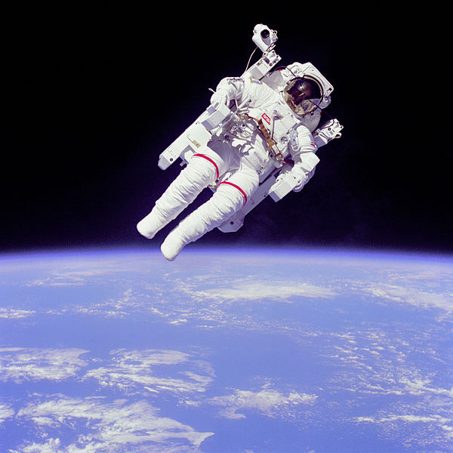 | 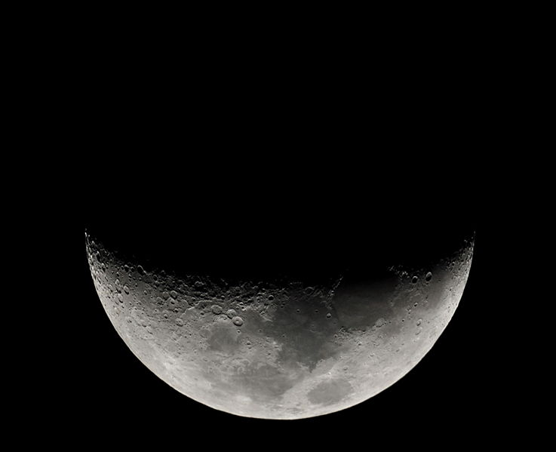 | 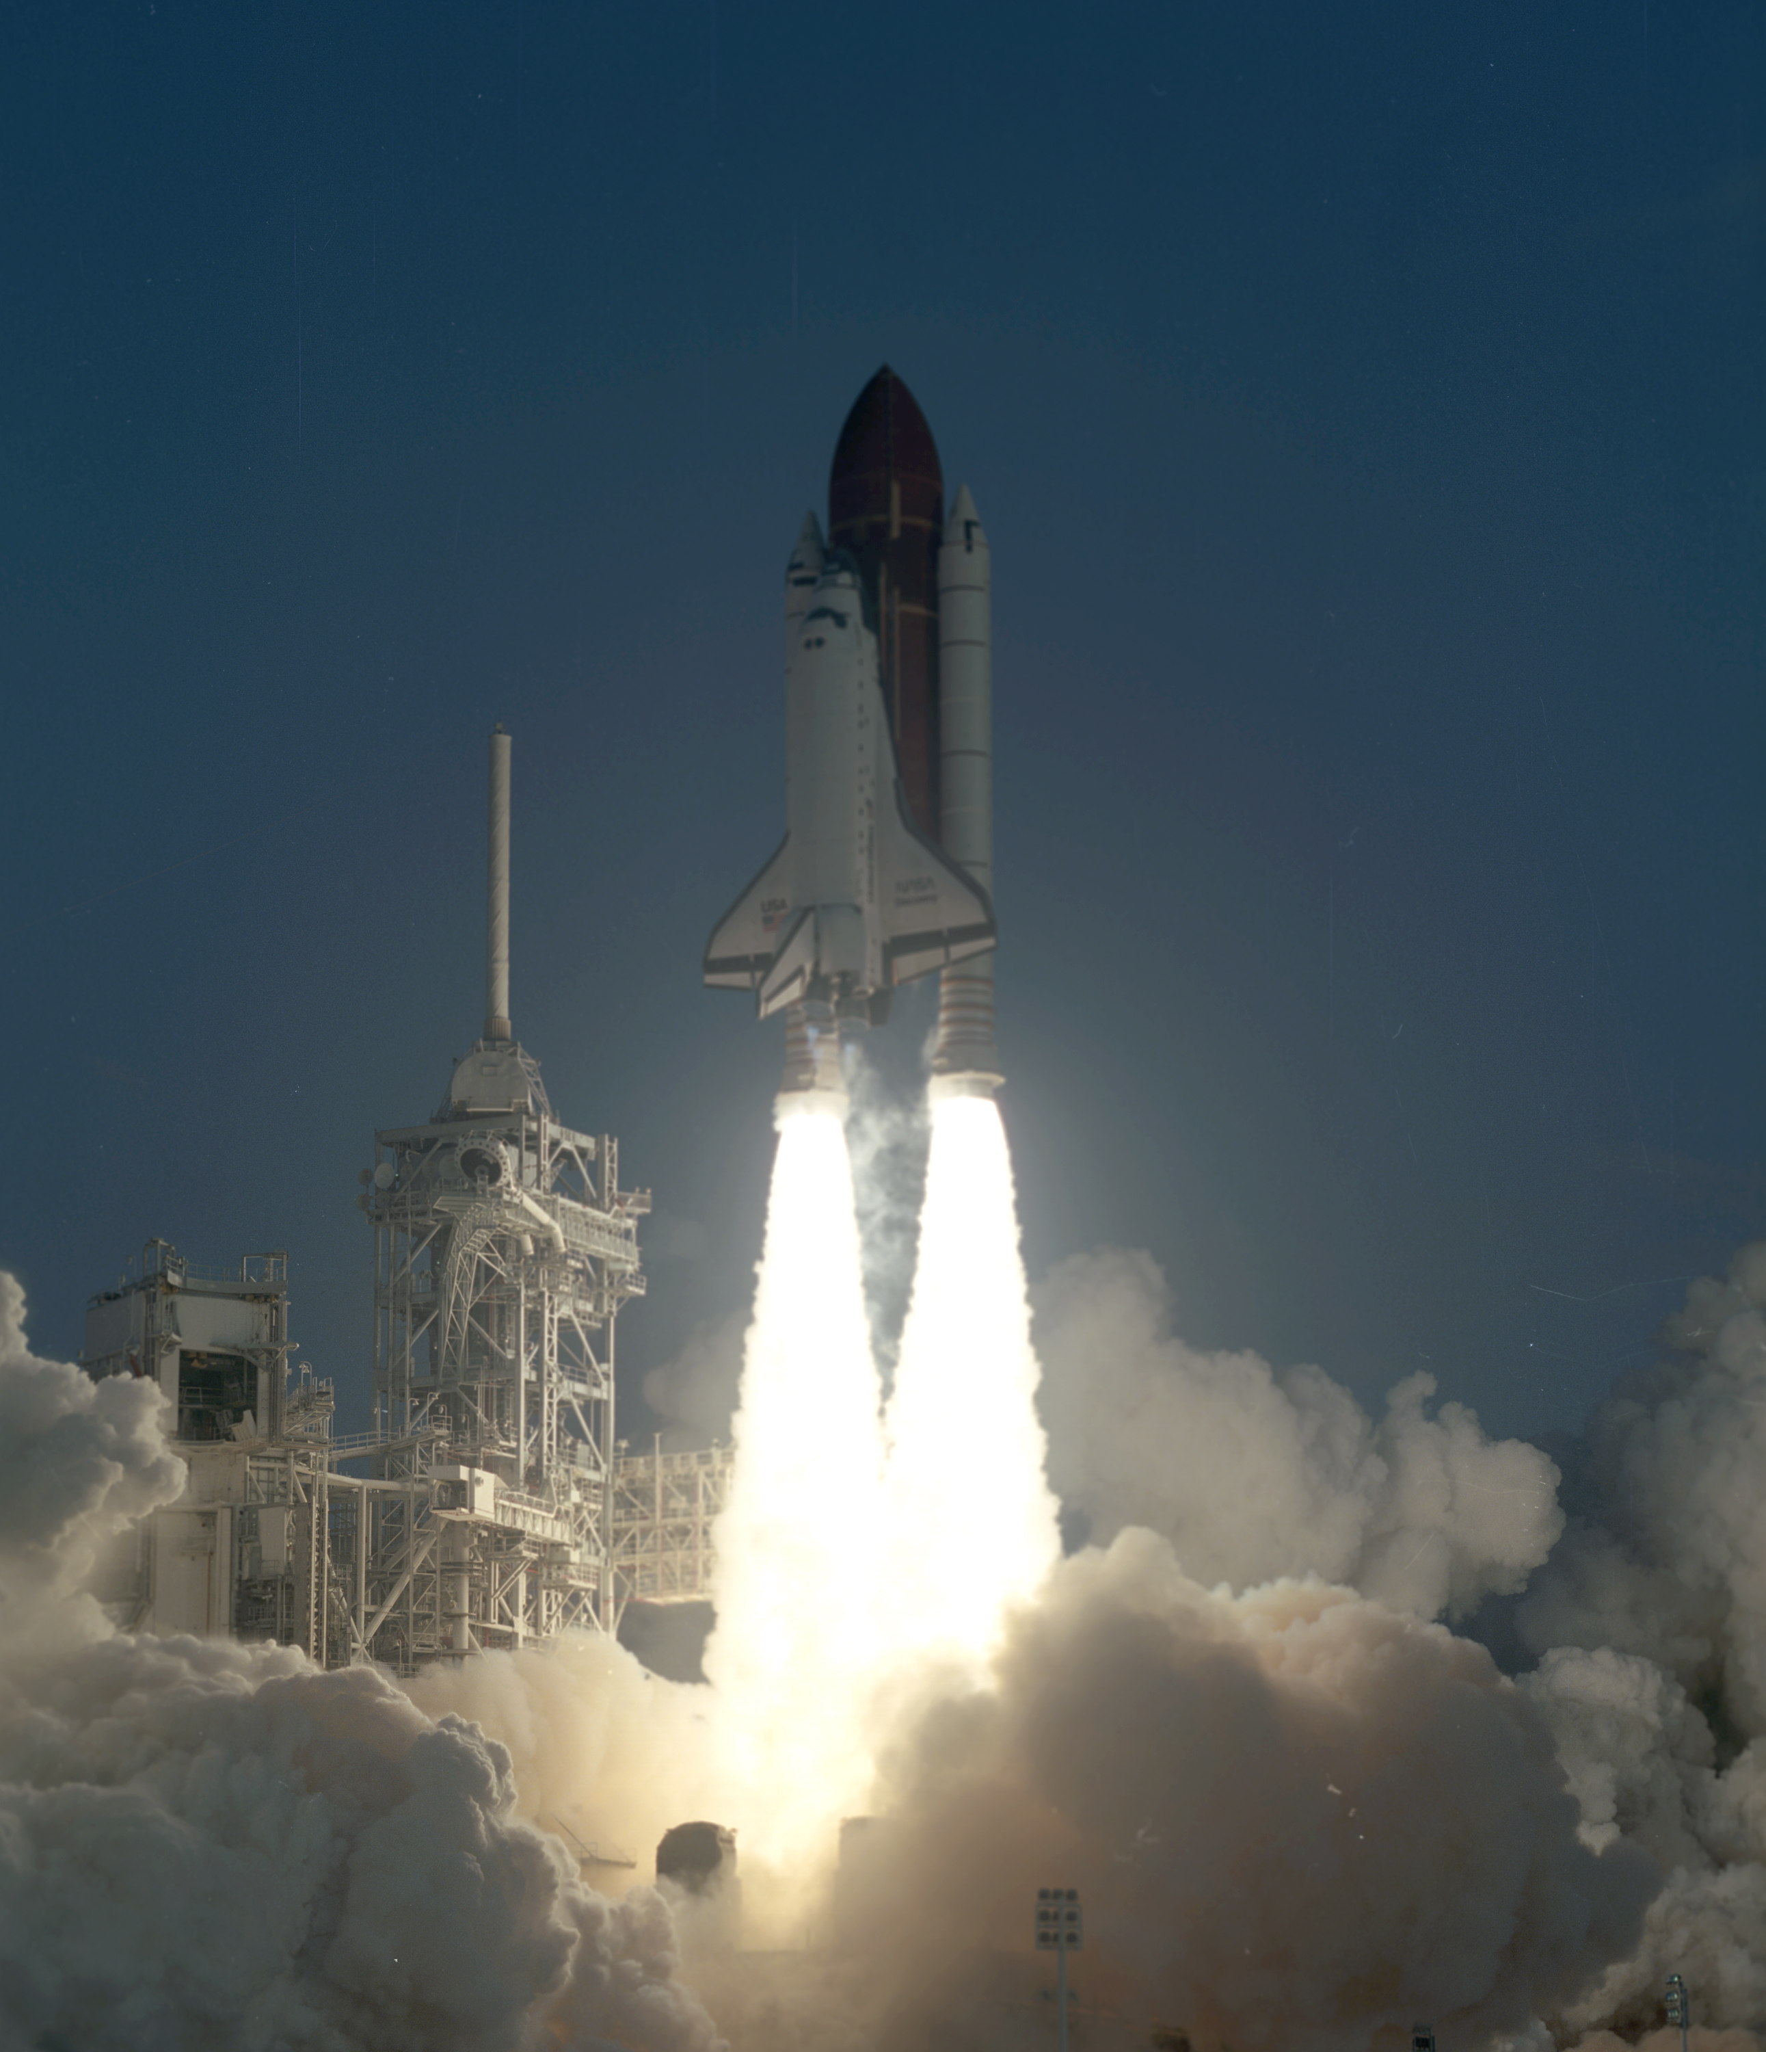
- Think about Space – you have two minutes to brainstorm as many words as you can related to space with your partner – go!
Now compare with your class – add any new vocabulary to your list.

- Discuss the questions below with your group:
- Would you like to travel in space? Why/ why not?
- How is traveling in space different from travelling on earth? What things would you need to take with you?
- Can you think of the names of any famous astronauts? What are they famous for?
- Do you think animals can travel in space? Do you know of any animals that have travelled in space?
- What films can you think of that are about space or set in space? Have you seen any of these films? What are they about?

- ‘Gravity’ is a film about two astronauts who get stuck in space. What do you know about this film? Tell your partner. Now read the text below and find out more.
In ‘Gravity’, Sandra Bullock and George Clooney play nervous new astronaut Dr Ryan Stone and experienced pro Matt Kowalsky, whose work on the Hubble Space Telescope is violently interrupted by a catastrophic debris collision. Cut off from ground communications and drifting in space, their only hope lies in making it to the International Space Station before Stone’s air supply runs out.
Text adapted from: http://www.timeout.com/london/film/gravity
Would you like to see this film? Why?
How would you feel if you were stuck in space? What would you do?
Vocabulary
- Match the vocabulary in the box with the correct meaning below.
orbit expedition collision
satellite floating gravity thriller

- ________________: A machine sent into space that moves around the sun, moon, earth or a planet.

- ________________: To follow a repeated circular path around a star or planet.

- ________________: A journey taken with a particular purpose.

- ________________: An exciting film with lots of action and suspense.

- ________________: Two moving objects violently crashing into each other.

- ______________: To rest on top of liquid or to move freely in the air.

- _____________: The natural force that pulls things to earth.

- These adjectives are all found in the text you will read next. Choose the correct meaning for each one.

- Serious
- Giving a lot of attention to something.
- Very funny.

- Lucky
- Having bad fortune.
- Having good fortune.

- Important.
- Not serious.
- Having serious meaning.

- Emotional
a) Causing strong feelings.
b) Feeling very happy.

- Isolated.
- With lots of people.
- Separate from everyone else.

- Excited
- Feeling very enthusiastic.
- Feeling very tired.

Reading
- Read the article below quickly. What is it about? Tell your partner.

The 3-D space thriller Gravity stars Sandra Bullock and George Clooney as astronauts fighting for their lives 372 miles above Earth. Cady Coleman is the astronaut who helped Bullock to prepare for her role of spacewoman Dr Ryan Stone. Coleman talks about how she shared her experiences with the film star by telephone and email while orbiting Earth aboard the International Space Station.
“It was really clear that Sandra’s a serious actress,” says Cady Coleman, 52, a veteran of two space shuttle flights and a three-month expedition aboard the ISS.
“Living and working in space is a privilege that so few of us have been lucky enough to experience. I was excited that she wanted to speak to me to understand the conditions and the challenges of space.”
Talking to Bullock was like “talking to a friend”, said Ms Coleman. “She wanted to know about how we moved up there – about floating in micro-gravity, how your hands and your feet move, how we use our feet for stopping,” said Ms Coleman.
As mothers, they also spoke about the personal and emotional side of space travel, another important theme in the film after the disaster.
“We talked about what it was like to be up in space without your family and knowing you’re so far away and isolated,” said Ms Coleman.
In the film, the shuttle is destroyed in a collision with a satellite. Stone and her crewmate Matt Kowalski are left tied to each other floating in space. Communication links with Earth have been lost, meaning the astronauts must find a way home, or die. Watch the film to find out what is going to happen next!

- Now choose the best title for the article.

- Gravity: Why this film is so great.
- Gravity: The astronaut who inspired Sandra Bullock.
- Gravity: The astronaut the film is about.

- Read the text again and answer the questions.

- Who is Cady Coleman?
- Where was Cady when she communicated with Bullock?
- How did they communicate?
- What experience does Cady have as an astronaut?
- In addition to practical advice what else did the women talk about?
- Who else starred in the film alongside Bullock?
- Why are they lost in space?

Grammar: Be going to.
- Look at the sentences below. Underline the verb each one uses.

- Watch the film to find out what is going to happen next!
- I’m going to be an astronaut when I grow up.
- We’re not going to play football tomorrow.

- What verb form do the sentences use to talk about future plans?
- What is the negative and question form?

- Complete these sentences with the correct form of ‘be going to’

- I ______________(not go) to the party unfortunately as I have other plans.

- We’re _____________(see) that new space film on Friday night – I can’t wait!

- __________(you/clean) your bedroom any time soon? It’s a mess!

- This summer my family and I ___________(travel) to Australia!

- You _____________ (not wear) those shoes are you? They aren’t suitable for hiking.

- I ___________(have) a hot bath and go to bed early tonight.

- Write 5 sentences about your future plans. Make 3 of them true and 2 of them false. Write them below.

- _______________________________

- _______________________________

- _______________________________

- _______________________________

- _______________________________
Read your sentences to your partner – can they guess which are true and which are false?

Listening

http://www.youtube.com/watch?v=AZx0RIV0wss

- You’re going to watch a video about food in space. What things do you think it will mention? Work with a partner and make a list.

- Now watch and tick the items on your list that you see or hear about in the video.

- Now watch the video again and complete the missing information in the sentences below.

- In the early days food was mainly brought to space in tubes and dehydrated __________.
- Today, astronauts have a good __________ of food.
- They decided to use __________ as a substitute for bread.
- The problem with bread is that the crumbs _______ away rather than falling to the floor.
- A tortilla can last for _________months in space.
- The bubbles in the honey sit in the ____________ instead of the bottom.
- There’s no sink or running __________ on the space station.

- If you went into space, what food would you miss the most? Why? Compare with your partner/group – did you say the same things?

Speaking

- Listen to your teacher say these sentences. What do you notice about the pronunciation of ‘to’?

I’m going to clean the house tomorrow.
I’m going to study more for my next exam.
I’m going to travel to the US next year.

- Sandra wants to speak to Cady about her role in Gravity to find out more about life in space. Ask and answer questions about what you are doing throughout the day so that you can find a suitable time to telephone each other.

Work with a partner. Decide who is person A and who is person B.
Person A – you are going to be Sandra Bullock.
Person B – You are going to be Cady Coleman.
Look at your diary page below.
Use be going to to talk about your future plans.

A. Sandra Bullock’s Diary
6am - Wake up
7am – Breakfast meeting with director
9am – Gym for yoga class.
11am - Hairdressers
1pm – Lunch with friends
3pm – Meeting with producer
4-6pm – Spend time with family
9pm – Attend movie premier

B. Cady Coleman’s Diary
6am – Wake up/ shower and change clothes
7am – Eat breakfast
7.30am – 11.30am - Supervise experiments
11.30am – Break
12-2pm – Maintenance duties
2pm – Lunch
3-5pm – Supervise experiments
5.30-6.30pm – Exercise
7pm – Dinner
7.30pm – Free time to email, watch movies etc.
10pm – Bed

What time did you arrange to speak?

Tell your partner about any plans you have for next weekend.

Writing

A teen website has asked readers to write in with a blog post talking about their future. You are going to write an entry and email it to them.
First make notes on what you will write about. Use the questions below to help you.
- What plans do you have for your future in the next year? (Think about any special activities or holidays you are planning)
- What plans or intentions do you have for after taking ESO and for when you finish school?
- Do you know what job you would like to do in the future? Which one? Why?

Now write your blog entry. Don’t forget to use a variety of vocabulary and correct tenses.
Check your work for any spelling mistakes when you have finished.

________________________________________________________________________________________________________________________________________________________________________________________________________________________________________________________________________________________________________________________________________________________________________________________________________________________________________________________________________________________________________________________________________________________________________________________________________________________________________________________________________________________________________________________________________________________________________________________________________________________________________________________________________________________________________________________________________________________________________________________________________________________________________________________________________________________________________________________________________________________________________________________________________________________________________________________________________________________________________________________________________________________________________________________________________________________________________________________________________________________________________________________________________________________________________________________________________________________________________________________________________

Reading text adapted from:
http://www.telegraph.co.uk/science/space/10341495/Gravity-the-astronaut-who-inspired-Sandra-Bullock.html

Answers
Warm Up
Students’ own answers
Vocabulary
1.
- Satellite.
- Orbit.
- Expedition.
- Thriller.
- Collision.
- Floating.
- Gravity.

2.
- A.
- B.
- B.
- A.
- B.
- A.

Reading
2.
b.
3.
1. An astronaut.
2. Orbiting Earth aboard the International Space Station
3. By email and telephone.
4. She has done two space shuttles flights and a three-month expedition aboard the ISS.
5. As mothers, they also spoke about the personal and emotional side of space travel and being away from family.
6. George Clooney.
7. Their space shuttle gets destroyed in a collision with a satellite.

Grammar
1. is going to happen, I’m going to be, We’re not going to play
- Be going to + verb
- I am not/ + going to + verb.
He/she is not
We/you/they are not

Are you/we/they + going to + verb?
Is he/she …
2.

- I’m not going to go.

- Are going to see.

- Are you going to clean.

- Are going to travel.

- Are not going to wear.

- I’m going to have.

Students’ own answers.

Listening
3.
- Packets
- Variety
- Tortillas
- Float
- 18.
- Middle.
- Water.
Speaking

- ‘To’ becomes the weak form - /tə/
Drill the statements using the weak form
2. /3. Students’ own answers.

Writing
Students’ own answers

Images
Astronaut-EVA.jpg by NASA, via Wikimedia Commons
http://commons.wikimedia.org/wiki/File:Astronaut-EVA.jpg?uselang=es

The phase of Moon by 阿爾特斯, via Wikimedia Commons
http://commons.wikimedia.org/wiki/File:The_phase_of_Moon.jpg

STS-41 launch.jpg by NASA, via Wikimedia Commons
http://en.wikipedia.org/wiki/File:STS-41_launch.jpg

